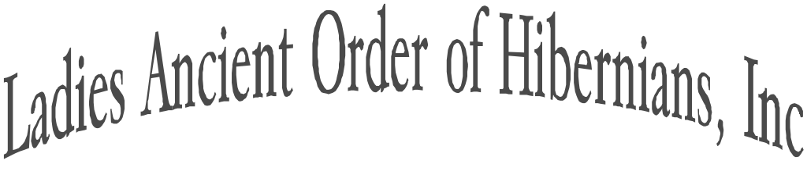
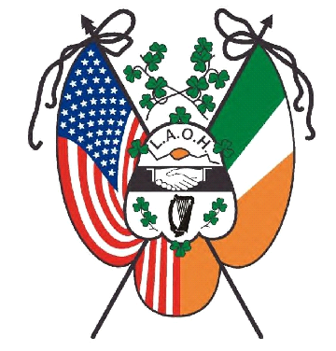

NATIONAL CHAPLAIN
Rev Fr. Ryan Duns, SJ

NATIONAL DEPUTY CHAPLAIN
Sr. Lisa Breslin, SSJ

NATIONAL PRESIDENT
Sandi Swift
natlpresidentlaoh@gmail.com
Phone-314-750-6907

NATIONAL VICE PRESIDENT
Cathy Turck
laohnationalvicepresident@gmail.com
Phone-518-369-2813

NATIONAL SECRETARY
Kathleen Diulus
natlsecretarylaoh@gmail.com
Phone-412-953-1875

NATIONAL TREASURER
Kim DePeaux
laohnationaltreasurer@gmail.com
Phone-518-461-5065

NATIONAL IRISH HISTORIAN
Mary McNamee
laohnationalhistorian@gmail.com
Phone-845-239-1315

NATIONAL MISSIONS & CHARITIES
Brianna Curran
laohnationalmissions@gmail.com
Phone-267-229-7034

NATIONAL OFFICE OF
CATHOLIC ACTION
Kathryn Brady
laohnationalca@gmail.com
Phone-401-258-0218

IMMEDIATE PAST NATIONAL
PRESIDENT & ORGANIZER
Mary Ann Lubinsky
laohnationalorganizer@gmail.com
Phone-570-617-7961

APPOINTEES
Auditor- Christina Parisi
Catholic Social Justice- Sr. Lisa Breslin
Convention Chair- Karen Keane, PNP
Freedom for All Ireland- Rita O‘Hara
Fundraiser- Molly Dobson
Immigration- Sandy Merrell
Legal Counsel- Ann Durkin Fisher, JD
Publications- Kalyn Populo
Public Relations- Marilyn Madigan, PNP
Social Media & Web- Maggie Brogan
Supplies- Kelly Hajek
Tax Expert- Kathryn Keane, EA
Veteran Affairs- Suzanne Messina
Young Hibernians-Natalie Peterinelli

Organized in 1894
Dear Sisters and Father Duns,

It has truly been an honor to be elected as your National Missions and Charities Officer for the 2026-2028 term. I look forward to working with the Mission and Charities Officers from across the county. I know we are going to accomplish great work together that will have an important and inspiring impact on those we support.

In case we have not met, my name is Brianna Maura Curran. I was born and raised in Bristol Borough, PA. I had the great fortune to be raised in a large Irish Catholic family. Every holiday, birthday, and event was filled with fun, laughter, and music and lots of family! I have traveled to Ireland to study, with my family, and twice for the FFAI trip. Below please see a photo of close to half of my family from my Uncle Jimmy’s 80th birthday this weekend. I still live in Bristol with my husband Nick and our Bullmastiff Tully (Tullamore). We keep very busy between Hibernian activities, work, volunteering, family, and friends. If you have an event, please let me know. We enjoyed traveling, supporting our fellow Hibernians, and Tully loves a good road trip!

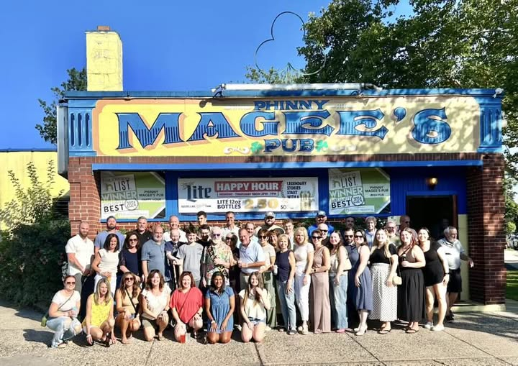

During the 2026 National LAOH Convention, the membership left me in awe due to your generosity for the Spirit of Saint Brigid fundraiser. Raising $14,500 in supplies and funds for Mater Filius of Nebraska in about 41 days. Your dedication to helping those in need inspires me to work harder and makes me proud to service our membership.

An item that was discussed during the Appeal for Aid pre-convention committee meeting was to raise additional funds over this two-year term for the Appeal for Aid. And one thing most Hibernians know about me is that I love promoting a fundraiser for a good cause. I have started researching an idea and I am waiting to hear back on the profitability margins. Once I have more information, I will share it with the State Presidents and State M&C Officers.

Important Information:
Address:
Brianna Curran
1516 Wilson Avenue
Bristol, PA 19007

Cell Phone: 267-229-7034
Email: laohnationalmissions@gmail.com
Website: https://ladiesaoh.com/missions-and-charities/

Please save the date of Wednesday, September 30th at 8pm EST for my first Missions & Charities Officers meeting. Please submit any questions by Wednesday, September 23rd. Zoom information will be sent out closer to the meeting.

Together with the help of the AOH, our families, and friends we will be able to make a positive impact on many individuals' lives. Please do not hesitate to reach out with questions or if you need any assistance. I am looking forward to the amazing work we will do together!
In Our Motto- Friendship, Unity and Christian Charity,
Brianna Curran
National Missions & Charities Officer
Ladies Ancient Order of Hibernians, Inc.
