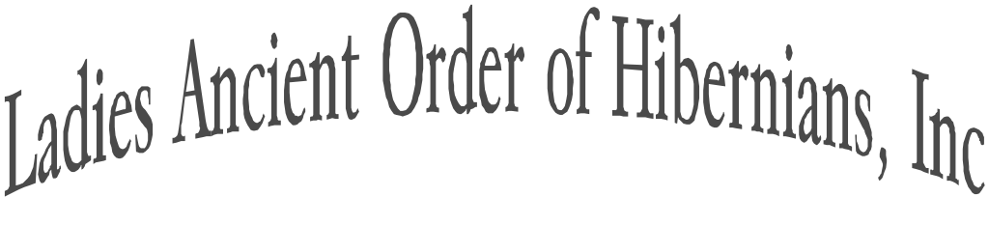
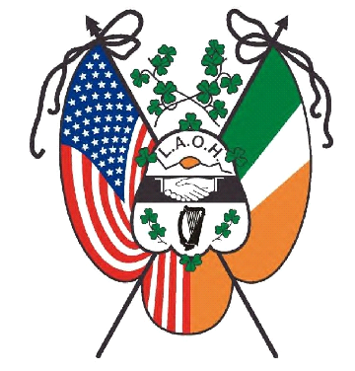

NATIONAL CHAPLAIN
Rev Fr. Ryan Duns, SJ

NATIONAL DEPUTY CHAPLAIN
Sr. Lisa Breslin, SSJ

NATIONAL PRESIDENT
Sandi Swift
.natlpresidentlaoh@gmail.com
Phone-314-750-6907

NATIONAL VICE PRESIDENT
Cathy Turck
laohnationalvicepresident@gmail.com
Phone-518-369-2813

NATIONAL SECRETARY
Kathleen Diulus
.natlsecretarylaoh@gmail.com
Phone-412-953-1875

NATIONAL TREASURER
Kim DePeaux
laohnationaltreasurer@gmail.com
Phone-636-331-3905

NATIONAL IRISH HISTORIAN
Mary McNamee
laohnationalhistorian@gmail.com
Phone-845-239-1315

NATIONAL MISSIONS & CHARITIES
Brianna Curran
laohnationalmissions@gmail.com
Phone-267-229-7034

NATIONAL OFFICE OF
CATHOLIC ACTION
Kathryn Brady
laohnationalca@gmail.com
Phone-401-258-0218

IMMEDIATE PAST NATIONAL
PRESIDENT & ORGANIZER
Mary Ann Lubinsky
laohnationalorganizer@gmail.com
Phone-570-617-7961

APPOINTEES
Auditor- Christina Parisi
Catholic Social Justice- Sr. Lisa Breslin
Convention Chair- Karen Keane, PNP
Freedom for All Ireland- Rita O‘Hara
Fundraiser- Molly Dobson
Immigration- Sandy Merrell
Legal Counsel- Ann Durkin Fisher, JD
Publications- Kalyn Populo
Public Relations- Marilyn Madigan, PNP
Social Media & Web- Maggie Brogan
Supplies- Kelly Hajek
Tax Expert- Kathryn Keane, EA
Veteran Affairs- Suzanne Messina
Young Hibernians-Natalie Peterinelli

Organized in 1894
August 9, 2026
Dear Sisters,
I am truly honored to have been appointed as National Legal Counsel on the Ladies Ancient Order of Hibernians, Inc. National Board by President Swift. For the past four years, I have been a member of LAOH Division 1 Savannah, Chatham County, Georgia. I am also serving as the Georgia State Board Freedom for All Ireland and Catholic Social Justice Education Committee Appointee. I previously was a member of LAOH Division 9, District of Columbia for over 30 years. As National Legal Counsel, my mission is to identify legal issues and other risks that could impact the Ladies Ancient Order of Hibernians, Inc.

I grew up in Dover, New Hampshire. I am a graduate of the University of New Hampshire with a BS in Chemical Engineering, New York University Graduate School of Business Administration with an MBA in Finance, and Georgetown University Law Center with a JD. I have worked as a chemical engineer for Exxon in New Jersey, a business planner and financial analyst for IBM in New York and Maryland, and associate for the law firm Chadbourne & Parke in Washington, DC. I currently provide litigation support for a variety of clients.

It is a privilege to serve as an appointee to the National Board and to provide support to our Order.

In Friendship, Unity and Christian Charity,

Ann Durkin Fisher
Ann Durkin Fisher
National Legal Counsel
laohnationallegalcounsel@gmail.com
301-461-0890

