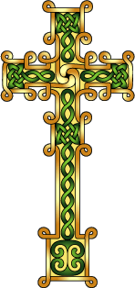
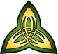
LAOH Capital District
Trinity Degree Team

Registration for Degrees
The exemplification of the Major Degrees of the Ladies Ancient Order of Hibernians
will occur on June 28, 2026, at The Schenectady Hibernian Hall: 1748 State St, Schenectady, NY at 2 p.m. Registration begins at 1:30pm and everyone must arrive and be seated by 1:50 pm.
All LAOH members are welcome and encouraged to attend.
Please complete the form below and mail with your check made payable to:
LAOH- Trinity Degree Team. Please send the check and Degree registration information to:
Kim DePeaux
108 W Creek Lane
Altamont, NY 12009

The fee is $25.00 per person for Candidates and $20.00 per person for Observers, prior to the June 15th deadline. After the deadline, the fee will be $30 for candidates and $25 for observers. The fee includes a candidate Degree card, and Pin. An optional certificate is available for a fee.
Please note that an Observer must have received her degrees to attend.
The deadline for registration is June 15th, 2026. For questions pertaining to the Degree, please contact Kimdepeaux@gmail.com or cathyturck33@gmail.com

I wish to attend the Major Degrees of the LAOH on Sunday, June 28th 2026 as a candidate or observer: (check one below)

_____ Candidate $25 _______ Certificate $5 (Optional) _______Candidate $30- late Reg.
_____ Observer $20 (Bring degree card) _______ Observer $25-late Reg.
PLEASE PRINT
Name__________________________________ Division Number AND County__________________________
Address_________________________________________________________
City ______________________________________State____________ Zip________________
Phone Number _____________________________ Email address_________________________________
Division President’s email_____________________________________

