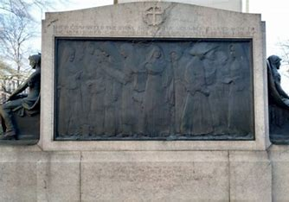

Centennial Nuns of the Battlefield Monument and Wayside Dedication
September 20_ 21, 2024
“To the memory and in honor of the various order of sisters who gave their services as nurses on battlefields and in hospitals during the Civil War”

Centennial Mass St. Matthew’s Cathedral
Saturday September 21 at 12:10pm

Hotel Accommodations
Phoenix Park
520 N. Capital Street NW
Washington D.C.
Limited Number of Rooms Available

Rates: $229 Single;$249 for Double Queen and $30 per day for Triple or Quad +taxes
Reservation Link
https://reservations.travelclick.com/75979?groupID=4248008 or
Toll free # 855-371-6824 and identifying themselves as being with Group Code: 25158 or Ladies Ancient Order Of Hibernians of America.
Booking Deadline for LAOH Rate 8/21/2024

Hosted by:
Ladies Ancient Order of Hibernians

Reservation Form
Name:
Address:
City: State: Zip:
Tel: E-Mail:
AOH LAOH Guest Military Veteran
Current Office:
Religious: Order:
Dinner Choice Chicken Salmon

Dinner—Saturday, September 21, 2024 at 5:00pm
Army Navy Club
901 17th St NW Washington D.C. 20006
Dinner: $100.00
RESERVATION DEADLINE: September 1, 2023
Please Make Checks Payable to Ladies Ancient Order of Hibernians.
Completed Reservation Form and Payment Should Be Mailed to:
Marilyn Madigan, 4375 West 182 Street, Cleveland, Ohio 44135

