National Board
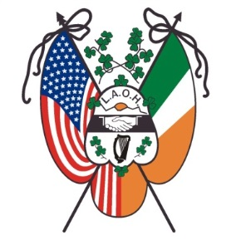

Traveling Degree Team

Registration for Degrees

The exemplification of the Major Degrees of the Ladies Ancient Order of Hibernians
will take place on Thursday, August 8th, 2024, at 11:00 a.m., at the LAOH National Convention – The Rosen Centre Hotel in Orlando, Florida. Registration begins at 10:00 a.m. and all candidates must arrive and be seated by 10:45 a.m. No walk-up observers will be accepted.

All LAOH members are welcome and encouraged to attend. Please complete the form below and mail with your check made payable to: LAOH, Inc. Send the check and Degree registration information to:
Kim DePeaux
108 West Creek Lane
Altamont, NY 12009

The fee is $30.00 per person for Candidates (which includes Degree card and Degree Pin)
and $20.00 per person for Observers. Observers may be limited to accommodate Candidates.
Please note that an Observer must have received her Degrees to attend.
The deadline for registration is July 24, 2024. For questions pertaining to the Degree, please contact Cathy Turck at cathyturck33@gmail.com or 518-369-2813

____________________________________________________________________________

I wish to attend the Major Degrees of the LAOH on Thursday, August 8th, 2024, in Orlando, FL

____ Candidate $30 ____ Observer $ 20

Name______________________________________ Division Number_______________
County of your Division___________________________________________________________
Address________________________________________________________________________
City ________________________________________State____________ Zip________________
Phone Number _____________________________ Email address_________________________________

