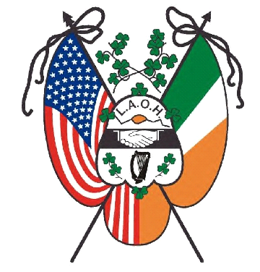
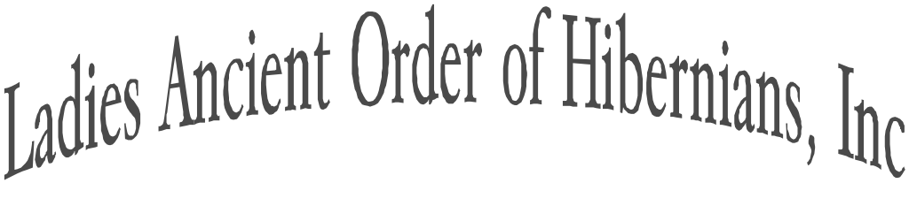

Organized in 1894

National Basket Raffle
2024 LAOH National Convention, Orlando FL
August 7th through August 10th, 2024

The LAOH National Board would like States to support the National Board by participating in the LAOH National Convention Basket Raffle by submitting gift baskets representing your State.

Prizes donated for the baskets and monetary amounts will be up to each State. Please ask your Divisions for support.

Keep in mind, many attendees will be flying to Orlando. Consider gift cards or gifts that would be easy to travel with.

Make your basket unique, show off your State and personalize it.

Thank you for your support & put the FUN in FUNdraising!!!

In our Motto of Friendship, Unity, and Christian Charity,
M$á$ire Leffel
LAOH National Fundraiser Chair

