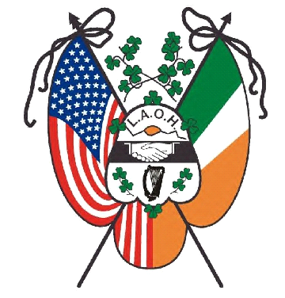
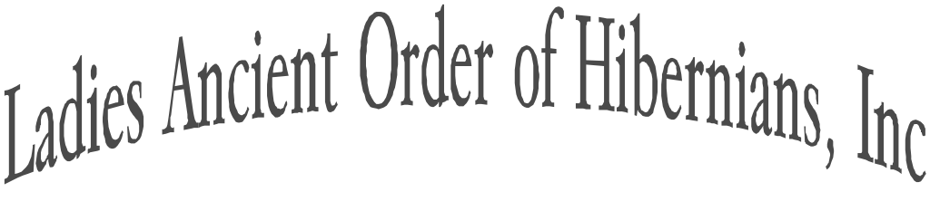

NATIONAL CHAPLAIN
Rev Fr. Ryan Duns, SJ

NATIONAL PRESIDENT
Marilyn Madigan
4375 West 182
Cleveland, Ohio 44135
natlpresidentlaoh@gmail.com

NATIONAL VICE PRESIDENT
Mary Ann Lubinsky
P.O. Box 186
Pottsville, PA 17901
laohnationalvicepresident@gmail.com

NATIONAL SECRETARY
Sandy Swift
2901 Orton Street
St. Charles, MO 63301
natlsecretarylaoh@gmail.com

NATIONAL TREASURER
Cathy Turck
108 West Creek Lane
Altamont, NY 12009
laohnationaltreasurer@gmail.com

NATIONAL IRISH HISTORIAN
Margaret Cornish
141 N. Kinsella Avenue
Covina, CA 91724
laohnationalhistorian@gmail.com

NATIONAL MISSIONS & CHARITIES
Natalie Peterinelli
4350 Regency Ridge Ct #204
Cincinnati, Ohio 45248
laohnationalmissions@gmail.com

NATIONAL OFFICE OF
CATHOLIC ACTION
Kathleen Diulus
117 Summit Dr.
Sewickley, PA 15143
LaohNationalCA@gmail.com

IMMEDIATE PAST NATIONAL
PRESIDENT & ORGANIZER
Karen Keane
2 Mill Hill Court Apt 314
Slingerlands, New York 12159
natlorganizerlaoh@gmail.com

APPOINTEES

Auditor-Christina Parisi
Convention Chair- Kathie Linton, PNP
Freedom for All Ireland-Dolores Desch
Fundraiser-Maire Leffel
Immigration -Siobhan Dennehy
Legal Counsel- Ann Durkin Fisher, JD
National News-Kim Depeaux
Political Education-Gail Dapaolito
Public Relations-Patricia Lavelle
Social Media & Web- Brianna Curran
Supplies- Mary Jo Rawlins
Tax Expert-Kathryn Keane, EA
Veterans AffairsCathie Norton Doherty

Organized in 1894

Sister Hibernians, December 18, 2023

I am attaching the LAOH National History reports for the year 2023.
As voted on at convention the report due dates have changed.
The new due dates are as follows:
Division reports are due to the county board (if applicable) by March 31, 2024.
If no County Board, they are due to the State by March 31, 2024.
County Board reports are due to the state by April 30, 2024.
State History reports are due to National Irish Historian by May 31, 2024.

It was also voted on at convention to levy a fine for Divisions, Counties or States that are non-compliant. The fines are the same as for the annual reports.
I have put an excerpt below from the History report that was submitted and voted on at convention 2022.

It is the duty of the State Historians to review and organize reports by county and send in one report to the National Irish Historian.

If you have any questions, please feel free to contact me.

EXCERPTS from History report 2022.
A motion was made by Patricia O’Connell and seconded by Stacy Blair, MI, that report dates be changes to Division reports due March 31, County (if applicable) April 30th and State reports to National by May 31st. Motion Carried.
The Chair informed the committee that at the time of this convention meeting there are still States that have not submitted reports. She further stated that there is no consequence for said action. Discussion ensued. A motion by Marilyn Madigan, NB, and second by Patricia O’Connell, NB, that fines for non-compliance should be the same as the fines for the annual reports. The Division level fine of $25.00 for first 7 days and then the second 7 days $25.00 more and then suspension. County level (if applicable) fine of $50.00 for first 7 days and second 7 days $50.00 more and then suspension of County. The State Board will be accessed $100.00 for the initial 7 days and then second 7 days $100.00 more with suspension of all activities of State Board for non-compliance. Motion carried.

Yours in Friendship, Unity, and Christian Charity,

Margaret (Peggy) Cornish
141 N. Kinsella Ave
Covina, CA 91724
626-331-3905
LaohNationalhistorian@gmail.com

