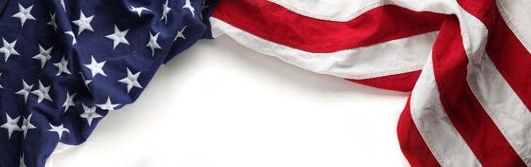

**LAOH National President**

**Marilyn Madigan**

**A Woman**[**Admired**](https://www.google.com/search?q=admired&si=ACFMAn_otZSKbpzAqD_RvWk4YSL-yt78OR8Jg65AusWu8bwSGv8NWW9zQ5BMltT54JbPCyk_EsW2XAKwzSu-ZRntBQJk3LW-9w%3D%3D&expnd=1)**for Her Courage, Outstanding Achievements, and**

**Noble Qualities**

**Testimonial Celebration**

**November 9th - 11th, 2023**

**Hampton Inn**

**24601 Country Club Boulevard**

**North Olmsted, OH 44070**

[https://www.hilton.com/en/book/reservation/deeplink/?ctyhocn=CLEOMHX&groupCode=CHHAOH&arrivaldate=2023-11-10&departuredate=2023-11-12&cid=OM,WW,HILTONLINK,EN,DirectLink&fromId=HILTONLINKDIRECT](https://www.hilton.com/en/book/reservation/deeplink/?ctyhocn=CLEOMHX&groupCode=CHHAOH&arrivaldate=2023-11-10&departuredate=2023-11-12&cid=OM,WW,HILTONLINK,EN,DirectLink&fromId=HILTONLINKDIRECT,)

**Booking Deadline for LAOH Rate 10/25/2023**

**Hosted by:**

**Ladies Ancient Order of Hibernians**

**Cleveland Divisions**

**Our Lady of the Rosary**

**Deirfiur of Charity**

**Reservation Form**

Name:

Address:

City:       State:       Zip:

Tel:       E-Mail:

AOH LAOH Guest Military Veteran

Current Office:

Division:       County:

Attending Meeting Yes No

**Dinner Dance—Saturday, November 11, 2023**

West Side Irish American Club

8559 Jennings Road, Olmsted Township, Ohio 44138

*Dinner: $65.00 with a Cash Bar*

Guest Name:

**Shake Rattle n Roll to the Music of Kennedy and Riley**

**RESERVATION DEADLINE: November 1, 2023**

Please Make Checks Payable to **LAOH**.

Completed Reservation Form and Payment Should Be Mailed to:

Sharon Kelty, 4606 West 158th Street, Cleveland, Ohio 44135