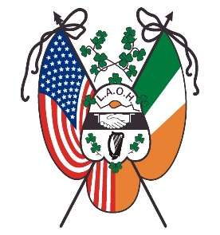

Ladies Ancient Order of Hibernians, Inc.
Application to receive the Degrees of the Order

LAOH MAJOR DEGREES
The Major Degrees of the Order will be exemplified by the Ohio State Degree Team on Sunday, 10:00 A.M. at the 2023 Ohio State Convention. Holiday Inn - Eastgate, 4501 Eastgate Boulevard, Cincinnati OH 44245.
Any members who have received their Degrees are invited to observe the ceremony and renew the true spirit of Hibernian’s. Convention website is ohioaoh.com/state-convention
RESERVATIONS ARE REQUIRED
Registration for candidates will be $20.00. (Exemption: Religious)
Observers attending the ceremony will be $10.00. (Exemptions: Religious & National Bd.)
All candidates, observers, and those that are exempt must fill out the registration form.
Please return your check payable to the LAOH Ohio Degree Team with the completed registration form by June 1, 2023, to:
Mrs. Maire Manning, 1435 Olivewood Avenue, Lakewood, OH 44107-4410
(216)228-5352 home answering machine; (216) 456-5395 (text).
email: manningrince@gmail.com

REGISTRATION FOR DEGREE CEREMONY

I wish to RECEIVE /OBSERVE (circle) the Major Degrees of the LAOH, Inc. to be conferred on Sunday, 10:00am, June 25, 2023, at the Ohio State Convention in Cincinnati.

Make checks payable to: LAOH Ohio Degree Team
Deadline: June 1, 2023
____ $20.00 Candidate ____ $10.00 Observer ____ Religious ____National Bd.
(Please Print)

___________________________________ _________________________________
Name Division Name & Number

___________________________________ ________________________________
Street Address City State Zip Code

___________________________________ ______________________
Email Address Phone Number

Observer Degree Information : ___________ ____________ ________________ _
(Bring Degree card) Date Received Degree Team Location

SPECIAL NEEDS: _______________

