Media Contact  Tami Ellen McLaughlin  Executive Director  Sober St. Patrick's Day®  tami@soberstpatricksday.org  646-942-0234 | 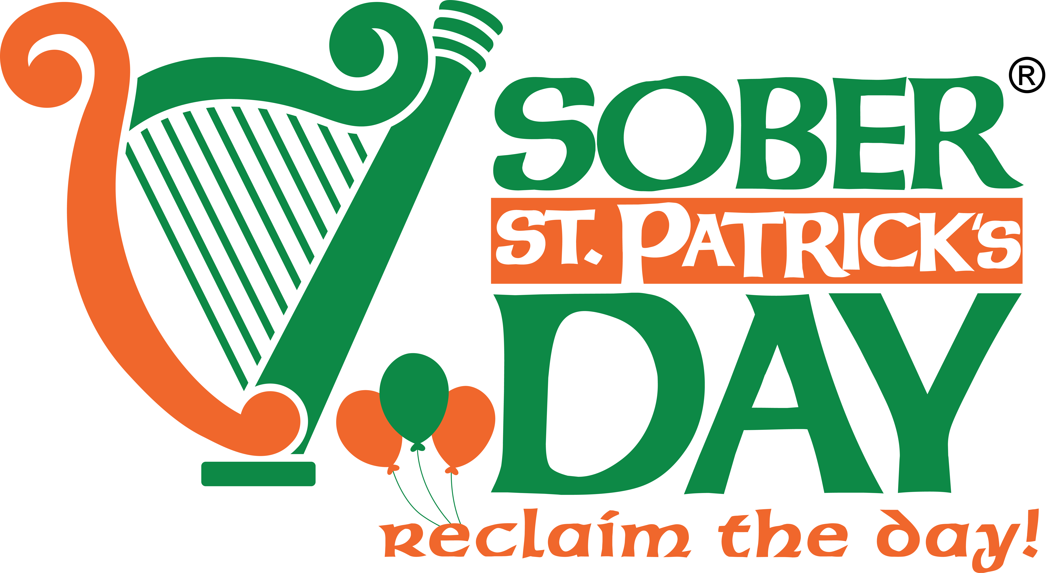 | 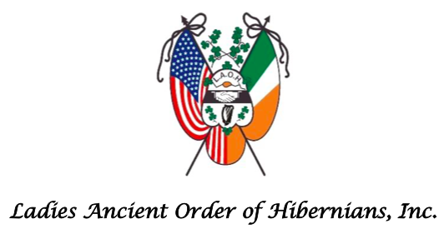 | 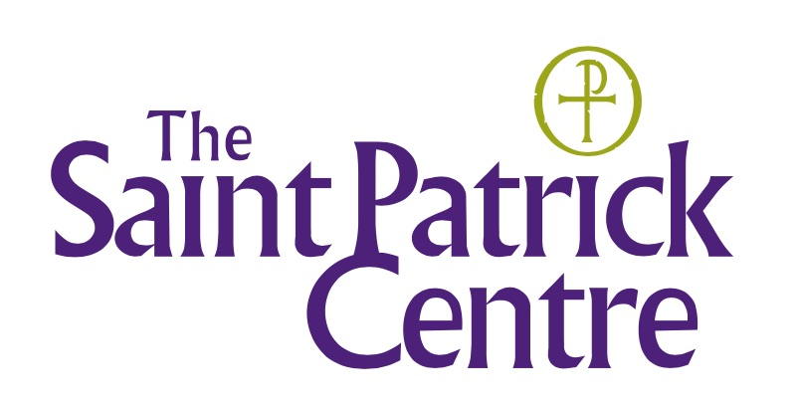

Rediscovering St. Patrick’s Day™ Livestream Book Club Launches on January 22, 2023
Sober St. Patrick's Day® & Ladies Ancient Order of Hibernians Collaborate on Who St. Patrick Really Was

NY, NY January 11, 2023 — Ireland’s patron saint has long been shrouded in legend, but the true story of St. Patrick is far more inspiring than the myths. As the soon-to-be run up to the saint’s feast day approaches, two Irish American organizations are partnering to launch a new digital initiative for the global diaspora to learn about the life of Saint Patrick and what he did for the "isle of saints and scholars.”

The Rediscovering St. Patrick’s Day™ Livestream Book Club ’s inaugural book — The Letters of Saint Patrick – a Historical New Translation by Marcus Losack, was recommended by Dr. Tim Campbell, Director, The Saint Patrick’s Centre in Downpatrick, NI, one of a number of experts on the life and legacy of St. Patrick.

- The club will meet via Zoom Webinar at 2 p.m. in NYC / 7 p.m. in Ireland on (3) Sundays: 1/22, 2/5, and 3/5.

- The book is 100 pages in large print, and participants can purchase the hard copy and/or Kindle version on amazon. https://a.co/d/iZyT8Dt

Partnering to Promote and Protect Irish Culture and Heritage
William Spencer Reilly is Founder/Chairman of Sober St. Patrick's Day® Foundation, Inc., which is dedicated to “reclaim the day.” Mr. Reilly explains that a livestream book club was the next logical digital program that his team is excited to curate. “As part of our mission statement, we want to help folks better appreciate who St. Patrick really was, and what he left behind for all of us to ponder. This little book does exactly that, and so thanks to The Saint Patrick’s Centre in Downpatrick, NI, we want to bring together the vast Irish community so we all can better appreciate who we’ll be celebrating this March 17th.”

Marilyn Madigan is National President of the Ladies Ancient Order of Hibernians (LAOH), the largest Irish American Catholic Women's Organization. Ms. Madigan shared that there is early and strong interest from national membership, and looks forward to inviting LAOH Junior members to join the book club as well. “The LAOH as an organization has always focused on promoting the true meaning of the day. This Book Club will help us learn about St Patrick in his own words.”

Irish Government Investment is Key
Both organizations are recipients of Irish Government Emigrant Support Programme (ESP) funding in support of their missions to promote and protect Irish heritage and identity overseas. Sober’s St. Patrick’s Day and Ladies Ancient Order of Hibernians are proud to partner on this new digital initiative to strengthen ties with the diaspora. The Irish Government investment in their respective heritage projects help support fostering a vibrant sense of Irish community and identity.

Two Ways to Join Free Book Club: Online Zoom Webinar and In-Person

- Registration is required: https://us02web.zoom.us/webinar/register/WN_6tUK355pSt-LXjz_Dihs0Q

- Important: Sober St. Patrick's Day Board Member Elizabeth Stack, PhD, Executive Director, Irish American Heritage Museum, is hosting this Zoom Webinar. Your Rediscovering St. Patrick’s Day Livestream Book Club Registration Confirmation email will be sent from Irish American Heritage Museum no-reply@zoom.us.

- Venue for in-person meeting is 33 Club, 323 East 33rd, between First and Second Avenues NY, NY, 10016.

###

