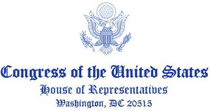

July XX, 2022

The Honorable Joseph R. Biden, Jr.
President of the United States of America
The White House
Washington, DC 20500

Dear President Biden,

As we approach 25 years since the signing of the Good Friday Agreement, we strongly urge you to appoint a U.S. Special Envoy for Northern Ireland. Recent turmoil in Northern Ireland and the stalemate in reestablishing Northern Ireland’s devolved government following its May elections continues to threaten the peace and stability brought about by the Good Friday Agreement. This letter follows up on a letter I and many of the signatories below sent to you on May 13, 2021, urging this appointment as soon as possible.

Mr. President, as you well know, the United States has played a powerful role in ensuring peace and maintaining stability in Northern Ireland. Many of my predecessors and current colleagues in Congress worked tirelessly, as good-faith actors, to negotiate the Good Friday Agreement. This includes former Special Envoy Senator George Mitchell and former Speaker of the House Tip O’Neill. Furthermore, each prior administration since President Clinton has appointed a Special Envoy. It is clear that U.S. leadership and investment in Northern Ireland is both valued and appreciated as well as helpful in facilitating peace and reconciliation. Bearing these facts in mind, the appointment of a Special Envoy will undoubtedly facilitate further peace and continues the longstanding commitment from the U.S. to peace on the island.

Along with general uncertainty regarding leadership in Westminster, Northern Ireland and the key principles underlying the Good Friday Agreement, currently face dire, targeted threats from two pieces of legislation. Specifically, the House of Commons is currently considering a bill that would unilaterally disregard the agreements made under the Northern Ireland Protocol and concurrently, the House of Lords is now reviewing legislation providing amnesty to individuals who committed potential crimes during the Troubles, limiting future prosecutions of potential crimes and impeding justice. These measures undermine international law, threaten to create a trade war between the European Union and the United Kingdom (Protocol Legislation), and risk almost 25 years of progress resulting from the Good Friday Agreement.

Mr. President, the Good Friday Agreement remains the framework to resolve the issues of today and to ensure peace and prosperity tomorrow. We strongly urge you, given your strong, resolute, and personal commitment to peace in on the island of Ireland, to appoint a Special Envoy to continue the historical role of the U.S. in facilitating compromise and negotiations in Northern Ireland and to ensure peace and stability remain in Northern Ireland.

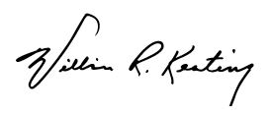
Sincerely,

William R. Keating
Chair
Subcommittee on Europe, Energy,
the Environment, and Cyber

