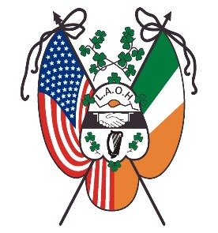
Ladies Ancient Order of Hibernians, Inc.
National Board
Established 1894
Office of the National President
Marilyn Madigan

July 30, 2022

Dear Sisters,

Our members demonstrated at the Convention that they are engaged. As the National President, I want this engagement to continue. I have reached out to several members to serve as Chairs on AdHoc Committees. I am grateful for those Sisters who accpted to serve our Order on these AdHoc Committees. Kathleen Norris of Maryland will serve as the Chair of the Marketing Committee. Carol Sheyer, Past National President will serve as Chair on the Committe to look at how we can shorten the Business sessions at the National Convention. Sandy Merrell of Missouri will serve as Chair on the Committee to develop a new LAOH Award. Our younger members are our future. We need to keep our younger members engagd. I have requested that Amanda Bacque to serve on a Committee that will be open for all members under 50.
At the Convention, I was given a list of tasks. Here is a list of the tasks already accomplished.

- A Chair was appointed to serve on a Committee to look at shortening the Business Section of the National Convention.

- The Appeals for Aid Guidelines will be developed by the Missions and Charities Officer and was addressed in her Introduction Letter.

- The Catholic Action Officer addressed in her Introduction Letter that the Project St. Patrick Cards updating is in progress and included an updated Catholic Action Forms. She also addressed the Committee to create meaningful Catholic Action Report of Divisions activities.

- The FFAI Chair has already started to plan for the Commemoration of the 25th Anniversay of the Good Friday Agreement.

- The deadline for submission for the Hibernian Herald is August 1. Please send your information and articles. To subscribe or send articles to the Hibernian Herald and Constant Contact, please email laohnationalnews@gmail.com.

Please share this letter with the County and Division Presidents and the members of your state. Please ask your members to join one of the Committees. State Presidents should send me a list of members interested in joining any of the AdHoc Committees.

I am here to serve you, our members, if you have any questions or concerns, please reach out to me at natlpresidentlaoh@gmail.com. If you rather talk by phone, call me at 216-470-3773.

