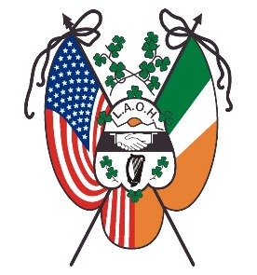
Ladies Ancient Order of Hibernians, Inc.
National Board
Established 1894
Office of National Catholic Action
Peggy Cornish

Dear Sister Hibernians,

Our help is needed in Ukraine and their bordering countries where there are already 2.9 million people in need of aid. LAOH members are asking how they can help. We have always been very generous in times of trouble; the corporal works of mercy tell us what to do. We are asking all members, Divisions, Counties and State Boards to help our sisters and brothers in the Ukraine.
The LAOH is taking a collection that is going to be distributed to Catholic Relief Services. They are on the ground in Ukraine, Poland, and all surrounding countries. The suggested donation is $50.00 per division. We will thankfully accept all donations both large and small from our individual members as well as from our divisions, counties, and state boards.
Make checks out to: LAOH Inc with Ukraine in Memo.
Mail to: Peggy Cornish
141 N Kinsella Ave, Covina CA, 91724.
We know that this time of year is a remarkably busy one for all of us. Please pass this on to all members so they may send their donations as quick as possible.
As much as the Ukrainian people need the physical necessities of life they also need our prayers. We ask all our members to say three Hail Marys every day for peace in the world. We know what it means to come from a war-torn land; let us not forget our sisters and brothers in the Ukraine.
Lest we forget the words of St. Pope John Paul II – “in the words of the Compendium of the Social Doctrine of the Church by the Pontifical Council for Justice and Peace – “Peace is founded not only on human rights but also on respect for the rights of peoples, in particular the right to independence.” (Page 69. #157). And the same pope famously taught us: “Peace is the fruit of solidarity.” (Sollicitudo rei Socialis, ‘On Social Concern’, no. 38. December 30, 1987). “
Your prayers and support will make a huge difference. I say to you my sister Hibernians let us all
“Go boldly into the darkness and be the light”.
Yours in Friendship, Unity and Christian Charity,
Peggy Cornish
National Office of Catholic Action
Ladies Ancient Order of Hibernians, Inc
141 N. Kinsella Ave
Covina, CA, 91724
626-331-3905

