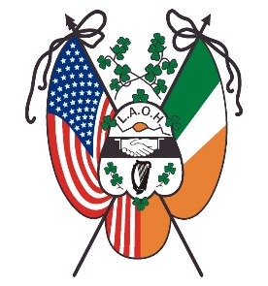
Ladies Ancient Order of Hibernians, Inc.
National Board
Established 1894
Office of the National Vice President
Marilyn Madigan

March 4, 2022

Sisters,
This is an exciting time for our Order assembling at the first National Convention since the Covid Pandemic. I know that many of our members are interested in receiving the Degrees of our Order at this upcoming Convention. The Claddagh Degree Team of Allegheny County Pennsylvania will be exemplifying Degrees. The Degree Ceremony is scheduled on Saturday July 16, 2022. Degree Registration is scheduled at 8:30 am with the Degree Ceremony to start promptly at 9:00am.
From the National Constitution: “DEGREES Section 4. The Degrees of our Order are an essential part of being a member of the Ladies Ancient Order of Hibernians, Inc. Each member, when receiving the Degrees, is shown the grand history of the Irish people and Catholic Faith, the importance of women in that history, and is sworn to a solemn obligation that is taken as Degreed members. Every member wishing to advance in the leadership of this Order, as well as every member wishing for a deeper understanding of the Order, is encouraged to take the Degrees as soon as possible after initiation, or as soon as made available. The importance of the Degrees cannot be put into words and must be experienced by each member to be fully understood.”
I would encourage our members to receive their Degrees. For those who have already received their Degrees, please observer the Ceremony to support your Sisters as well as recommit to this essential part of our Order.
Any questions, please contact the Claddagh Degree Peggy Cooney, Director at 412.921.6348 - email at peggy.cooney@ymail or Patti Flaus, Guardian at 412.427.4728 - email at pfpalaoh@gmail.com

Yours in Friendship, Unity and Christian Charity
Marilyn Madigan
laohnationalvicepresident@gmail.com
216-470-3773

