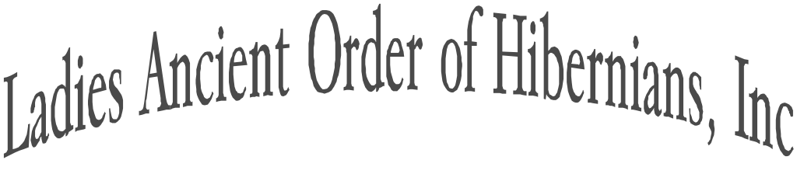

NATIONAL CHAPLAIN
Rev Fr. Ryan Duns, SJ

NATIONAL PRESIDENT
Karen Keane
108 Kennewyck Circle
Slingerlands, NY 12159
natlpresidentlaoh@gmail.com

NATIONAL VICE PRESIDENT
Marilyn Madigan
4375 West 182
Cleveland, OH 44135
laohnationalvicepresident@gmail.com

NATIONAL SECRETARY
Mary Ann Lubinsky
P.O. Box 186
Pottsville, PA 17901
natlsecretarylaoh@gmail.com

NATIONAL TREASURER
Sandi Swift
2901 Orton Street
St. Charles, MO 63301
laohnationaltreasurer@gmail.com

NATIONAL IRISH HISTORIAN
Mary T Leathem
37 Dormay Lane
Troy, New York 12182
nationallaohhistorian@gmail.com

NATIONAL MISSIONS & CHARITIES
Cathy Turck
P.O. Box 170
Altamont, NY 12009
laohnationalmissions@gmail.com

NATIONAL OFFICE OF
CATHOLIC ACTION
Margaret Cornish
141 N Kinsella Avenue
Covina, CA 91724
LaohNationalCA@gmail.com

IMMEDIATE PAST NATIONAL
PRESIDENT & ORGANIZER
Carol Sheyer
121 South B Street
Hamilton, OH 45013
natlorganizerlaoh@gmail.com

APPOINTEES

Auditor-Christina Parisi
Convention Chair- Kathie Linton, PNP
Freedom for All Ireland-Dolores Desch
Fundraiser-Maire Leffel
Immigration -Siobhan Dennehy
Legal Counsel- Ann Durkin Fisher, JD
Newsletter Editor- Kim Depeaux
Political Education-Gail Dapolito
Press Relations-Beth Zuczek
Social Media & Web- Brianna Curran
Supplies- Mary Jo Rawlins
Tax Expert-Kathryn Keane, EA
Veterans AffairsCathie Norton Doherty

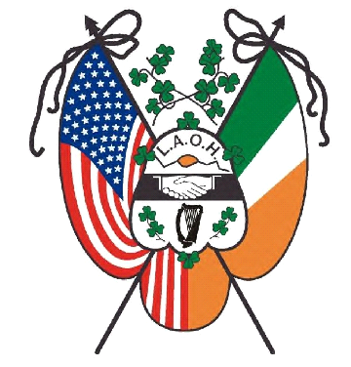
Organized in 1894
March 1, 2022

Greetings sisters,

I hope this letter finds you well as you prepare to celebrate Irish American
Heritage month. As many of you will be celebrating our Patron saint, St. Patrick, please remeber and pray for the people of Ukraine.

On another note, it is time to consider submitting applications for the National LAOH Appeals For Aid Fund. Per our consitution, Article XV, Section 8, paragragh G under the Duties for the Missions and Charities Officer you will find:

“Appeals for Aid are intended to provide limited aid to charities at the National Convention. All appeals for aid requests must be from a 501(c)(3) charity and submitted to the Missions & Charities Officer 45 days prior to the Convention.
The Missions & Charities & Appeals for Aid Committees will bring these recommendations to the National Convention delegates for approval.”

Attached you will find a fillable form that can be downloaded and completed. Please note that there are several attachments required to be submitted with the application. All fully completed applications will be reviewed by members of the Appeals for Aide comittee at the upcoming National Convention in Pittsburgh, PA. Recommendations from the committee will be put forth at the National convention for the approval of the mebership.

This application will also be placed on the LAOH website under the Office of Missions and Charities. If you have any questions please reach out to me at laohnationalmission@gmail.com Completed applications may be emailed to me
or sent by US mail to: Cathy Turck, PO Box 170, Altamont, NY 12009

**** Due date for applications is May 30, 2022 ******

Yours in Friendship, Unity, and Christian Charity,

Cathy Turck
Cathy Turck

