Freedom For All Ireland – Dolores Desch – 16 December 2021
News from the North of Ireland: This week there were two very significant rulings regarding legacy cases. The first is that the High Court in Belfast ruled that survivors and relatives of those murdered in the Miami Showband massacre are to be awarded nearly £1.5m in total damages to settle claims over suspected collusion with the loyalist terrorist murderers. News article: Belfast Telegraph Miami Showband payout. Collusion. Was the murder of these innocent bandmates preventable? This case was the subject of a Netflix documentary called Remastered: The Miami Showband Massacre. Another case that gained worldwide attention this week was the UK Supreme Court ruling that the Police Service of Northern Ireland (PSNI) decision in 2014 to discontinue an investigation into allegations of controversial interrogation techniques (aka torture) against the “hooded men” was unlawful. The 14 hooded men were subjected to a series of controversial interrogation techniques when they were interned without trial by the Army in Northern Ireland in 1971. See News Article: Ruling on Hooded Men investigation.

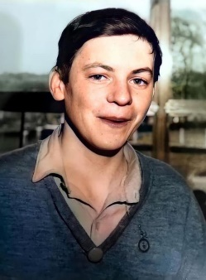
This week also marked the 50th Anniversary of the murder of Martin McShane by the British Army. Martin was 16 years old, unarmed and playing inside a GAA field with his friends when he was gunned down. Over 30 shots were fired at him; he was shot seven times in the back. The investigation was typical for the era when a Catholic was shot. No one has ever been held accountable for Martin’s murder despite the efforts of his family. A candlelight vigil was held by his family and friends this week to not only remember Martin but to demand Justice. It is cases like these that drive us to continue the fight for Justice. When someone asks why there needs to be a Freedom for All Ireland Christmas Appeal or why we need a FFAI Chair please share these stories with them. It is through education that we become engaged in helping our brothers and sisters in Ireland. I have seen a significant increase in our members’ engagement and interest in FFAI over the past few years and let’s not only keep that going but push further. Irish America is a significant force when it comes to Irish Issues.

Christmas Appeal: Our FFAI Committee held a Christmas Appeal Raffle which was off the charts! Thank you to all our supporters. We managed to sell out the 100 squares in a record 5 days! National President Karen Keane pulled two winning numbers #50 – Catherine Reinholdt and #2 – Mary Waters Szwedowski who split the $1,250 winnings. We raised $1,250 that went directly to the Christmas Appeal!

Donations from Divisions, Counties and State boards continue to arrive thanks to the generosity and commitment of our members. If your division has not yet gotten their donation in there is still time! Donations received by January 15, 2022 will be included in the current Christmas Appeal and will be handed out on the FFAI trip in late January/Early February. Donations received after the January 15th date will be included in the next (2022-2023) Christmas Appeal. Please mail all donations from Divisions, Counties and States directly to me and forward a copy of the donation to your State FFAI Chairperson. My mailing address is Dolores Desch 20 Arlene Ave. Albany, NY 12203. Checks need to be made payable to LAOH, Inc. Also please include the entity information - Division, County Board or State Board that is making the donation, contact name, email, phone, and mailing address and if the donation is earmarked for a specific group please provide that information. At this point we expect the following groups to be included in the disbursement of funds: Ballymurphy Families Committee, Bloody Sunday Trust (Museum of Free Derry) Bridges Beyond Boxing- Belfast, Down Patriot Graves, Duchas Oiriall, Ealu, Greater New Lodge Commemoration Committee, Green Cross, Jim O’Neill and Robert Allsopp Memorial Flute Band, National Graves Association-Belfast, National Graves Association-Tyrone, The Passionist Peace and Reconciliation Office (Holy Cross), Relatives for Justice, St. Patrick's Center- Downpatrick, The Witness Project - Sean Murray. For more information on the groups we support you can view the webinar where each group was presented with their checks from the LAOH and the AOH and discussed their program on the AOH YouTube Channel: AOH YouTube.

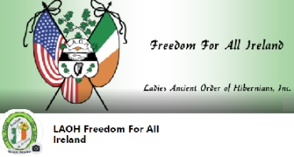
Presidents, please make sure your Division has an FFAI appointee who will receive and relay the latest information on the news, issues and programs affecting those living in the north of Ireland. FFAI information is readily available on our national website page and Facebook Page. I am also happy to assist if you need any help. Please like, follow, and share our FFAI Page https://ladiesaoh.com/freedom-for-all-ireland/ which is being updated with the latest FFAI news. If you are not receiving my emails, please send me your email address. As always, if you have any questions or would like more information please contact me at laohnationalffai@gmail.com. Thank you for your support for Freedom For All Ireland.

Go raibh maith agat.

