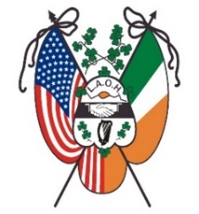
Ladies Ancient Order of Hibernians, Inc.
National Board
Established 1894
Fundraising, Maire Leffel
September, 2021

Dear Hibernian Sisters,
I hope all are well and I would like to thank you all for your support during our 2020-2021 National LAOH fundraising campaigns. So many Divisions, County, State and National Board members along with many individuals made this fundraiser a success. Congratulations to all the winners, some more than once!
Our LAOH National Board Fundraising campaigns helps defray the costs of our administrative expenses. We have many exciting things in the works, and I encourage everyone to visit the LAOH National website at www.ladiesaoh.com to stay informed of all events in which this campaign will contribute. Also visit Fundraising on our site to see the winners and additional ways you can help support our Organization.

Enclosed are 2 tickets, for $20.00 each, to buy as a Board or sell to individuals.
Please make that motion to purchase the tickets to support the LAOH, Inc.
30 chances to win!
6 months of Winners!
See the attached flier with more detailed information, and spread the word.
Get your tickets in fast to be eligible for the Early Bird Drawings
What a great stocking stuffer for Christmas!
Need more tickets or have any questions e-mail me at:
nationallaohrafflechair@gmail.com

In our Motto of Friendship, Unity and Christian Charity,
M$á$ire Leffel,
LAOH National Raffle Chair
17710 Flamingo Ave.
Cleveland, Oh 44135

