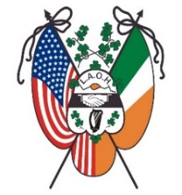

Ladies Ancient Order of Hibernians, inc.

National Fundraising Raffle
2021-2022

30 Chances to Win!
If you Win, your ticket goes back in the Bin!
6 months of winners

$100.00 Thanksgiving 2021, Early Bird Drawing

$100.00 Christmas 2021, Early Bird Drawing

$100.00 St Patrick’s Day 2022

26 weekly Monday winners for $25.00
(January 3rd, 2022 – June 27th, 2022)
$1,000.00 GRAND PRIZE
drawn at the 2022 LAOH/AOH National Convention

Tickets are $20.00 each
Make checks payable to: LAOH, Inc.
C/o M$á$ire Leffel, LAOH National Raffle Chair
17710 Flamingo Ave.
Cleveland, OH 44135
Need more tickets or have any questions, email me at: nationallaohrafflechair@gmail.com

What a great stocking stuffer for Christmas!
Get your entries in early to be eligible for the 2021 Early Bird drawings!

