2020 HISTORIAN END OF YEAR REPORTS

All 2020 history reports are in a google form. Here are some tips and the links for the reports will follow. States should have sent out all of the links to the Counties and Divisions. If you have any questions please contact either Past National President/Interim Historian Mary T. Leathem mtleathem@aol.com or National Vice President Marilyn Madigan laohnationalvicepresident@gmail.com

1) Please make sure you look over the form and have all your information on hand PRIOR to completing the report. You cannot save it and come back to it.

DO NOT HIT SEND UNTIL YOUR HAVE DONE STEP #2.

2) SAVE a copy of your report PRIOR to submitting it. Use your print command (CTRL P) and select SAVE AS PDF and save to your device. From there you can print a copy. On a non-Mac computer you would do CTRL P and it will open your print dialog box. Either print or save as a pdf to your computer. YOU WILL NEED TO EMAIL A COPY TO YOUR COUNTY/STATE HISTORIAN. The County and State will only need to submit their report. When divisions hit "Submit" it will go directly to National. In the event you forgot, or cannot print your report, please contact Mary T. Leathem or Marilyn Madigan for a copy.

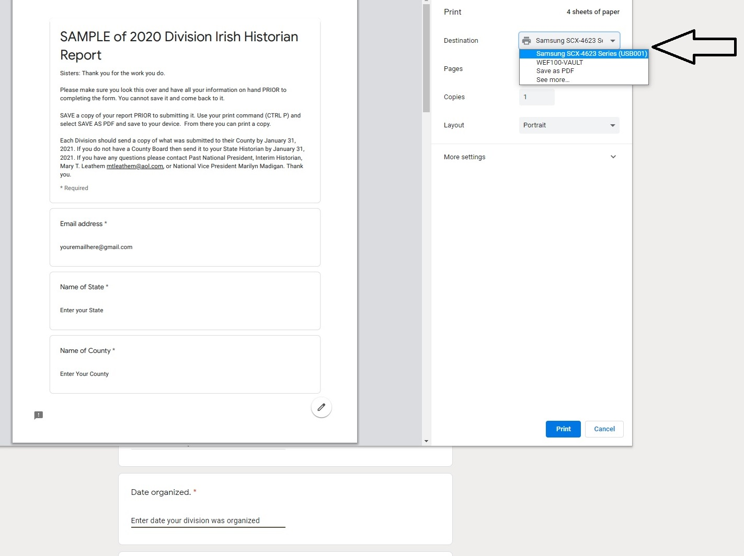
3) Please adhere to these due dates:

Divisions to County January 31, 2021
Divisions to State (if no County) January 31, 2021

County to State February 28, 2021

State to National March 31, 2021

If you did not receive the link from your State Historian, please use the correct one below.

Division Historian End of Year Report Form: https://forms.gle/1hejMG7RrMH6mVoZ7

County Historian End of Year Report Form https://forms.gle/BBqEMtmKJ2gZYBo78

State Historian End of Year Report Form https://forms.gle/msL8xj6ZqzmE23Mf9

