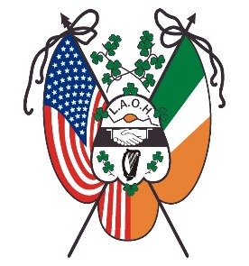
Division Tax & Assessment Bill
Your Tax Assessment is based on the membership reported on the “DIV Member Total” tab of the Division’s Membership Report, copied below.
Membership Summary
Membership Reported 12/31/2020 | 0
Membership Increase Stated in line A4 | 0
Subtotal Membership Increase (Add line C1 & line C2) | 0
Membership Decrease Stated in line B5 | 0
Membership Total Reported 12/31/2020 (Subtract line C4 from line C3) | 0
Number of Priests, Deacons, & Religious | 0
Number of National Board Life Members | 0
Total Non-Taxable 2020 Members (Add line C6 & C7) | 0
Total Taxable 2020 Members (Subtract line C8 from line C5) | 0

State:__________ County:________________ Division _____________________

National Per Capita $5.00 x Taxable Members (line 33) = $___________
State Per Capita $ x Taxable Members (line 33) = $___________
County Per Capita $ x Taxable Members (line 33) = $___________
National Nuns of the Battlefield and Appeals for Aid
$ 1.50 x Total Members (line 29) =$ ____________
TOTAL $_____________
Send your Division’s check for the Full Amount to the County, or State Treasurer if no County Board by January 31, 2021. Make check payable to the Ladies Ancient Order of Hibernians, Inc. and mail a copy of this bill with your check.
County or State Treasurer
Her Street Address
City, St, Zip

