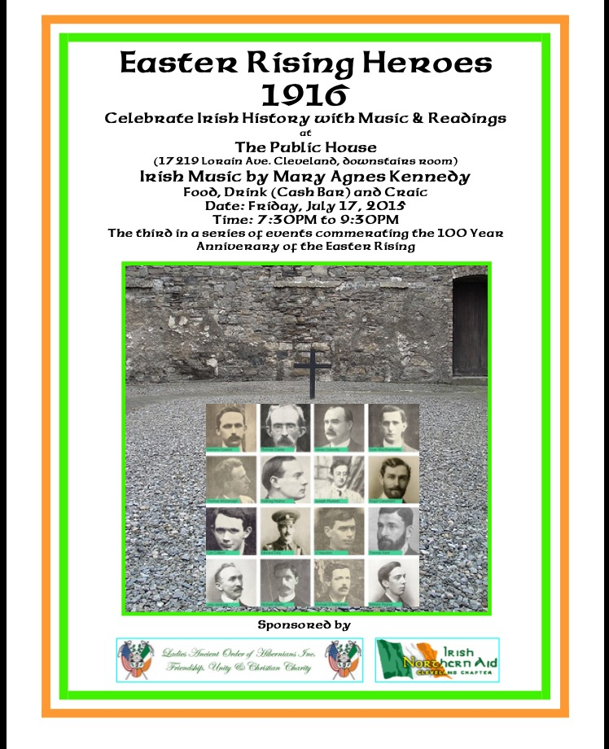

Cead mile Failte to the 3rd in a series of 1916 Commemorations sponsored by the LAOH and INA of Cleveland. Tonight we honor all the Men and Women who had a role in the Easter 1916 Rising whether in the planning or active participation.Irish America has always had a very important role in striving for Irish Freedom.
I would like to share a quote from George Washington "May the God in Heaven, in His justice and mercy, grant thee more prosperous fortunes and in His own time, cause the sun of Freedom to shed its benign radiance on the Emerald Isle."
1915-1916 was that time. On the death of O'Donovan Rossa on June 29, 1915 Thomas Clarke instructed John Devoy to make arrangements to bring the Fenian back home. I am proud that Ellen Ryan Jolly the National President of the LAAOH served as an Honorary Pallbearer the only woman at the Funeral held in New York.
On August 1 at Glasnevin the famous oration of Padraic Pearse was held at the graveside. We choose this week for this presentation because it was midway between these two historic events as well as being the Anniversary week of Constance Markeivicz death on July 15,1927. She was condemned to death in 1916 but as a woman her sentence was changed to prison for life. And so we remember those executed. We remember them in their own words and the remembrances of others.

Sixteen Dead Men by WB Yeats

O but we talked at large before
The Sixteen men were shot
But who can talk of give and take,
What should be and what not
While those dead men are loitering there
To stir the boiling pot?

You say that we should still the land
Till Germany's overcome:
But who is there to argue that
Now Pearse is deaf and dumb?
And is their logic to outweigh
MacDonagh's bony thumb?

How could you dream they'd listen
That have an ear alone
For those new comrades they have found,
Lord Edward and Wolfe Tone,
Or meddle with our give and take
That converse bone to bone

Easter Rising Heroes and the Date of Execution
May 3, 1916 Thomas Clarke, Thomas MacDonagh, and Padraic Pearse
May 4,1916 Joseph Mary Plunkett, Edward Daly, Michael O'Hanrahan, and William Pearse
May 5,1916 John MacBride
May 8,1916 Eamonn Ceannt, Con Colbert, Sean Heuston,and Michael Mallin
May 9,1916 Thomas Kent at Cork Detention Center
May 12,1916 James Connolly and Sean MacDiarmada
August 3,1916 Roger Casement

Poem by WB Yeats:

“ Yet I number him in the song; he too has resigned his part in the casual comedy. He too has been changed by his turn, transformed utterly; A terrible beauty is born……I write it out in a verse- McDonagh and MacBride and Connelly and Pearse, how and in time to be, wherever green is worn, are changed, changed utterly: a terrible beauty is born”

Pearse Oration at O’Donovan Rossa Service

“ They think they have foreseen everything, but the fools, the fools, the fools. They have left us our Fenean dead; and while Ireland holds these graves Ireland unfree shall never be at peace”

Roger Casement

“Self-government is our right, a thing born to us at birth, a thing no more to be doled out to us by another people than the right to life itself… the right to feel the sun, or smell the flowers, or love our kind.”

James Connolly

“Believing that the British government has no right in Ireland, never had any right in Ireland and never will have any right in Ireland; the presence in any one generation of Irish men ready to die to affirm that truth makes that government forever occupation and a crime against human progress. I personally thank God that I have lived to see the day when thousands of Irish men and boys and hundreds of Irish women and girls were ready to affirm that truth and to attest with their lives if need be”

James Connolly letter to his wife from prison Sept 3,1914 from Easter Widows

"Roddy, Ina and Nora should know that many more than I (perhaps thousands) will have to go to prison and perhaps, the scaffold, before our freedom will be won. Nothing worthwhile can be won without suffering."

James Connolly 1914 (Easter Widows)

Under his leadership, the Citizen Army was the 1st Irish Army to admit women to its ranks and give them a role. According to his daughter Nora, her father constantly said that " No movement was assured of success that had not a women on it." when some of the men complained that the women's section would be an encumbrance in the event of an Uprising. James responded that if none of the men turned out, the fight would go on with the women."

Nora Connolly (Easter Widows)

Intelligence Mission to New York Dec 1915. Her task was to give a message to Count Bernstoff the German Ambassador. Even 70 years later she refuses to talk about what she did:"I promised the leaders that I would never divulge it. I never said even though all those connected with it are now dead. Nora returned from New York in Feb 1916. She later recalled that it was not until St. Patrick's Day 1916, when she was in Dublin for a parade, that her father finally told her of plans for a Rising at Easter. "I think it must have been about March 1916, that Daddy told me definitely that the fight was to take place. He said "Are you coming with me? Will you be with me during the fight? " I was torn, because I had been with the Belfast contingent all the time. As I said, I had trained them. I said to him: After all, I should be with them in the North. The girls will have more confidence if I am there. And I wanted to be in Dublin with him. I did not know what to do. In the end, I decided to be with the Northern contingent."

James Connolly to his daughter Nora (Easter Widows)

"God protect you Nora, We may never see each other again." The Connolly sisters were shown the Proclamation of the Irish Republic, which had just been printed and told to memorize it, it would be too dangerous to carry an actual copy. Ina wanted to stay with her father, but he told her" It is not what you want or what I want, but is wanted of us that counts. You would not desert your countrymen in the north that need you more than we do here. There are plenty of women here to do your work...but if there is any fighting taking place up north, then that is your place."

James Connolly (Easter Widows )

"I was wounded twice yesterday and unable to move about, but have got my bed moved into the firing line, and with the assistance of your officers, will be just as useful to you as ever. Courage, boys, we are winning."

Easter Widows Before his death Connolly offered the soldiers forgiveness.

" brave men doing their duty."

Tom Clarke

from Glimpses of an Irish Felon's Prison Life

"Irish Freedom has gone on for Centuries, and in the course of it a well trodden path has been made that leads to the scaffold and to the prison.Many of our revered dead have trod that path, and it as these memories that inspired me with sufficient courage to walk part of the way along that path with an upright head."

From Easter Widows by Sinead McCoole

Tom Clarke "Does anyone think that I would expect or encourage other men to do that which I was not prepared to do myself." Kathleen, well aware of his commitment to the cause, asked him to consider her and their children and how they were going to suffer: he replied: "That can't be helped. My children will have to accept it the same as you. We are going to make a bid for freedom no matter what happens.

Tom Clarke wrote to his wife on April 30 from Richmond Barracks unfortunately the letter did not reach her for some weeks

"Dear K- I am in better health and more satisfied than for many a day- all will be well eventually - but this is good-bye and now you are ever before me to cheer me- God bless you and the boys. Let them be proud to follow the same path....I am full of pride my love."

Last meeting between Tom and Kathleen Clarke (Easter Widows)

Kathleen rushed to him saying"Why did you surrender? The last thing you said was no surrender." he replied "I know Katty, and I meant it. Had it rested with me there would have been no surrender...I was outvoted. I hoped to go down in the retreat from the GPO, but it was not to be." Kathleen "I don't know how I am to live without you. I wish the British would put a bullet in me too." He replied:. "It is not British policy to shoot women." Throughout their conversation she focused on not breaking down. "I knew that if I broke, it would break him, at least I feared it would, and perhaps leave him unfit to face the ordeal before him in a way he and I would like."

He entrusted to her a message for the Irish people: " We have struck the first blow for Freedom. The next blow, which we have no doubt Ireland will strike, will win through. In this belief we die happy"

Kathleen Clarke from her bio Revolutionary Women

"Tom came home from a meeting of the Supreme Council of the IRB and told me that it had been decided at the meeting to select some person whose discretion, silence and capability they could rely upon, one who would be made fully actuated with all their decisions. In the event of the arrest of all the members of the Supreme Council, the custodian of their plans and decisions would be in a position to pass on the work to those next in command, thus preventing confusion and temporary stoppage...I was very interested in all he was telling me, it was unusual for him to mention what happened at their meeting, so I was very surprised when he informed me that the person selected was myself."

Kathleen Clarke from Easter Widows

She was pregnant with their 4th child and made the decision not to tell Tom before the fight. He was she remembered "Full of hope for the future and admiration of his comrades in arms. In contrast Kathleen recalls "I was feeling that the world was tumbling around me, though I did not say so...as far as I was concerned my happiness was at an end."

Kathleen Clarke from Easter Widows

"I ached to join them there, and to be near my husband but hesitated, fearing that by disobeying orders I would only add to their worries."

Kathleen Clarke from Easter Widows

British Soldiers came to raid the Clarke house. As she recalled the soldier in charge had come "to question me about my men. He wanted to know where they were. were they out in the Rising? When I had last seen them? Was I in sympathy with them? I could have refused to answer, but I felt it would be letting my men down not to show I was with them, so I said that they were in the Rising and that I was in perfect sympathy with them, and very proud of them." Her defiant answers and demeanor resulted in her arrest.

Thomas MacDonagh

"Most Irishmen have grown up with the feeling, whether vague or clear, that the most noble thing for them in life after the service of their God would be to battle for Ireland"

"I am to die at dawn, 3:30 am 3rd May. I am ready to die, and I thank God that I die in so holy a cause. My country will reward my deed richly...For myself I have no regret. The one bitterness that death has for me is the separation it brings from my beloved wife Muriel and my beloved children, Donagh and Barbara...Never was there a better, truer, purer woman than my wife Muriel, or more adorable children...It breaks my heart to think that I shall never see my children again, but I have not wept or mourned. I counted the cost of this, and am ready to pay it. My wife and I have given all for Ireland. My dearest love, Muriel, thank you a million times for all you have been to me. I have only one trouble in leaving life -leaving you. Be brave, darling, God will assist and bless you. Goodbye, kiss my darlings for e. I send you the few things I have saved out of this war.Goodbye, my love, till we meet again in Heaven. I have a sure faith of our union there. I kiss this paper that goes to you. I have heard that they have not been able to reach you. Perhaps it is better so...God help and sustain you, my love. But for your suffering this would be all joy and glory. Goodbye"

John MacBride

" Many of you may live to fight other day. Take my advice-never allow yourselves to be cooped up inside a building again."

Eamonn Ceant

"Wrote a statement for the Irish people: guidance for other Irish Revolutionaries....never surrender...but fight to a finish...the enemy has not cherished one generous thought for those who, with little hope, with poor equipment, and weak in numbers, withstood his forces for one glorious week. Ireland has shown she is a Nation...I bear no ill will against whom I fought....I wish to record the magnificent gallantry and fearless, calm determination of the men who fought with me."

"My dearest wife not wife but widow before these lines reach you. Dearest silly little Fanny. My poor little sweetheart of many years ago. Ever my comforter, God comfort you now. What can I say? I die a noble death for Ireland's Freedom. Men and women will vie with one another to shake your dear hand. Be proud of me as I am and ever was of you. You have a duty to me and Ronan to live. My dying wishes are that you shall remember your state of health, work only as much as may be necessary and freely accept the little attentions which in due time will be showered upon you. You will be, you are the wife of one of the Leaders of the Revolution."

Sean Mac Diarmada

“I feel happiness the like of which I have never experienced; I die that the Irish nation might live”

Joseph Plunkett

“I am very happy I am dying for the glory of God and the honor of Ireland”

Michael Mallin

“I am satisfied I have done my duty to my beloved Ireland”

Among those who publicly critiqued the executions was George Bernard Shaw

"My own view is that the men were shot in cold blood, after their capture or surrender, we're prisoners of war and that it was therefore entirely incorrect to slaughter them..an Irish man resorting to arms to achieve the Independence of his own country is doing only what an Englishman will do, if it be their misfortune to be invaded and conquered by the Germans in the course of the present war."

In Conclusion we remember the Oration by Padraic Pearse at the Grave of O'Donovan Rossa

Life springs from death and from the graves of patriot men and women spring nations… They think they have pacified Ireland. They think they have purchased half of us and intimidated the other half. They think they have foreseen everything, but the fools, the fools, the fools. They have left us our Fenian dead; and while Ireland holds these graves Ireland unfree shall never be at peace”

____________________________________________________________

Quotes submitted by John Conway, Neil Gerrity, and Kathie Whitford Irish Northern Aid and Marilyn Madigan Ladies Ancient Order of Hibernians

